Two exchanges are being analyazed: Bitstamp and Coinbase from Dec-2015 to Dec-2019 in three intervals . The early interval is the early dataset 2016, second interval us middle pf 2017 and the third interval is 2018-2019.

There is some arbitrage profit opportunities to avail of in 2016 & 2017 for certain intervals, as seen from the graph of variance of 'close' data of Bitstamp and Coinbase. s However, in 2018 there is less variance as opposed to the earlier intervals.

As bitcoin matures with time, it is hard to find arbitrage profit opportunities over a period of time. As we see from the graphs, both exchanges kind of overlap each other with time and hence it gets hard to find any viable opportunities between coinbase and bitstamp.

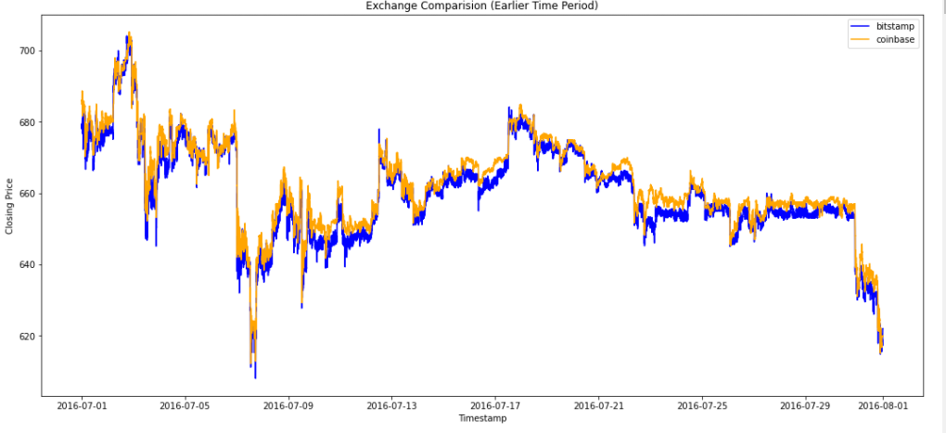

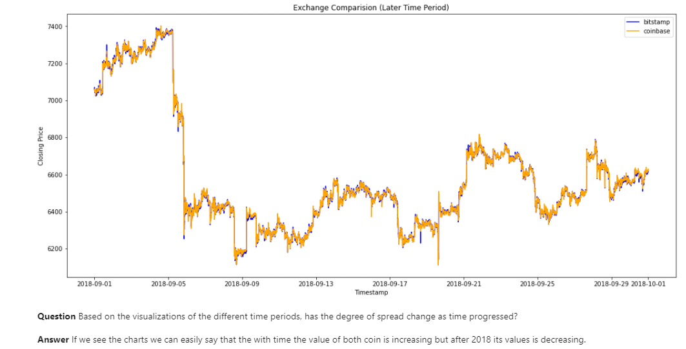

Picking a specific date

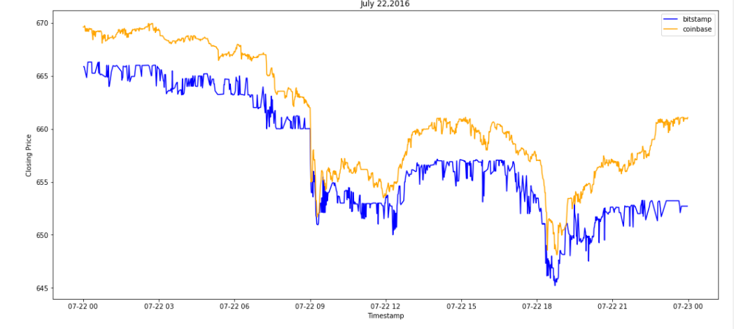

Box plot displaying the arbitrage spread

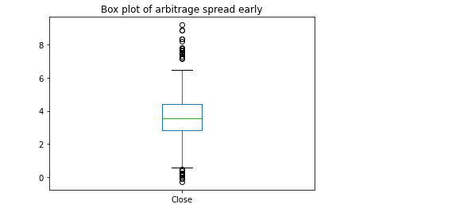

Cumulative sum of profits In the early stage exists

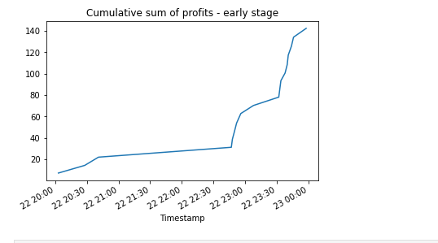

During the middle interval, it starts tapering off, but flatlining and in late stages, its barely non existent

